**ER DIAGRAM FOR SWIGGY ORDER MANAGEMENT SYSTEM**

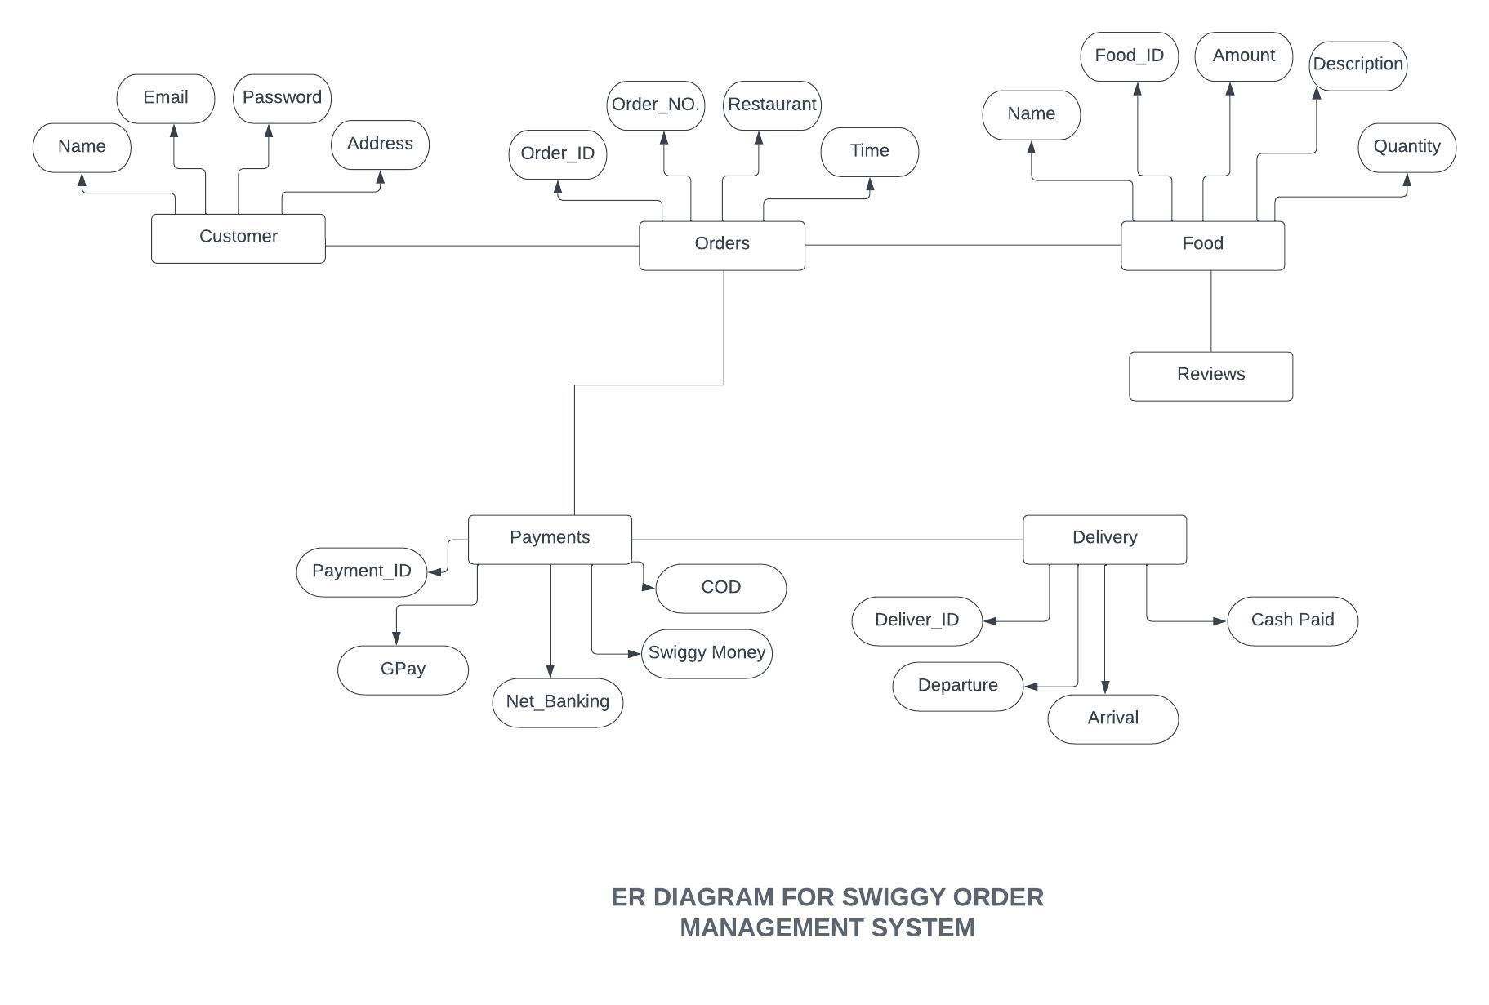

**Description:**

For our ER Diagram, we will have 6 entities:

* Customer
* Orders
* Food
* Payments
* Delivery
* Reviews

Attributes:

* Customer Entity has the following attributes:

1. Name
2. Email
3. Password
4. Address

* Orders Entity has the following attributes:

1. Order_ID
2. Order_NO.
3. Restaurant
4. Time

* Food Entity has the following attributes:

1. Name
2. Food_ID
3. Amount
4. Description
5. Quantity

* Payment Entity has the following attributes:

1. Payment_ID
2. GPay
3. Net Banking
4. Swiggy Money
5. COD

* Delivery Entity has the following attributes:

1. Delivery_ID
2. Arrival
3. Departure
4. Cash Paid

* Review Entity has the following attributes:

1. ⭐️
2. ⭐️⭐️
3. ⭐️⭐️⭐️
4. ⭐️⭐️⭐️⭐️
5. ⭐️⭐️⭐️⭐️⭐️

**Mapping Cardinalities:**

* One-to-One Relationship:

In this type of cardinality mapping, an entity in A is connected to at most one entity in B. Or we can say that a unit or item in B is connected to at most one unit or item in A.

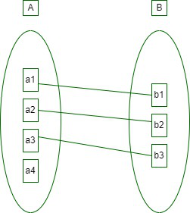

* One-to-Many Relationship:

In this type of cardinality mapping, an entity in A is associated with any number of entities in B. Or we can say that one unit or item in B can be connected to at most one unit or item in A.

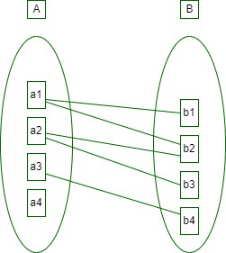

* Many-to-One Relationship:

In this type of cardinality mapping, an entity in A is connected to at most one entity in B. Or we can say a unit or item in B can be associated with any number (zero or more) of entities or items in A.

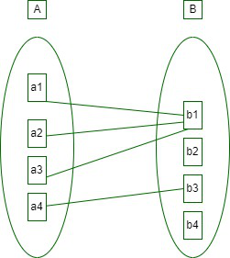

* Many-to-Many Relationship:

In this type of cardinality mapping, an entity in A is associated with any number of entities in B, and an entity in B is associated with any number of entities in A.

